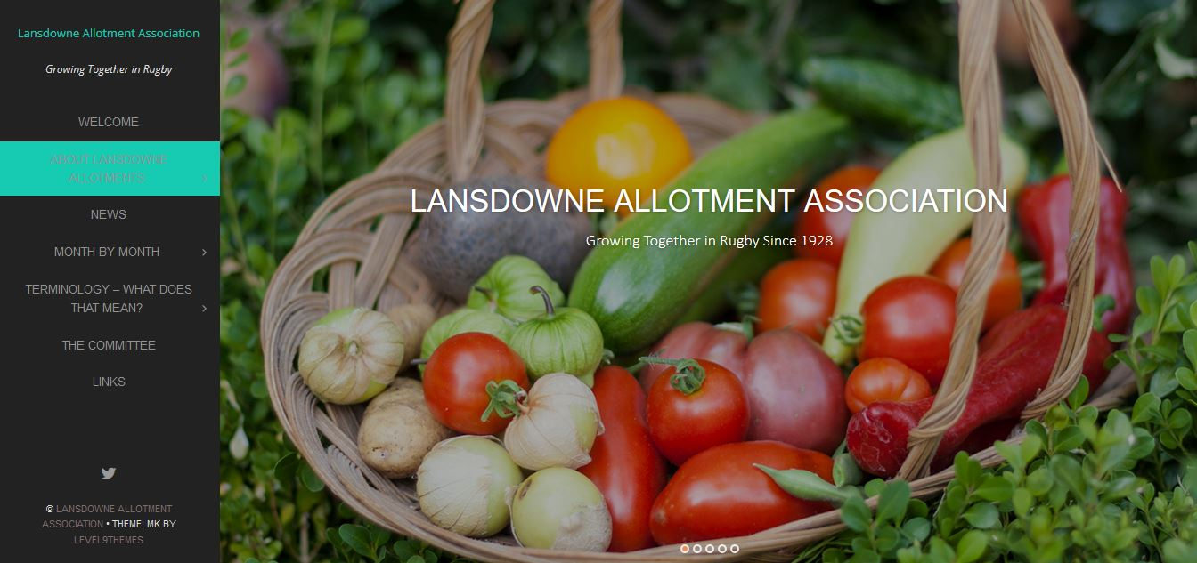

Firstly, whether you are a brand new member or have gardened here for any number of the 90 or so years that the site has existed, may I take this opportunity to welcome you to this, the next stage in the history of the old Eastlands’ allotments.

I think it is fair to say that none of us would have chosen to have gone down the route of devolved management had it not been forced upon us, but I have it on very good authority that it is just as well we seized the opportunity when we did, as future Council policy would possibly not have afforded us that chance and we may have ended up losing the site altogether.

Having been put in this position I feel it is our collective responsibility to protect the future of the site for both our current gardeners and for generations to come.

In the main, you should not notice any major changes on the site, but those you do notice will hopefully have a positive impact. We will not, for example, allow the deterioration of plots to the detriment of other plot holders as has so often been the case in the past. Paths, hedges and borders should be kept to a better standard and access to the committee for resolution of issues will obviously be much easier.

The first thing you will be aware of is the change of name to Lansdowne Allotments. It was felt that in the short term it was necessary to avoid any potential clash with the Eastland Gardeners’ Association and so a change of name was agreed upon.

You will also see a reduction in rates (they do include water, insurance and NAS membership) and the introduction of more quarter and half plots. It has become patently obvious in recent years that people these days cannot afford as much time to successfully manage and run a full plot, so, with the smaller sizes being offered, a mentoring scheme, advice available through the website and NAS membership and guidance, we will hopefully see better managed plots going forward.

I would also draw your attention to the website and twitter accounts. Please bookmark and follow us, as news and information will be made available on there as well as through the regular newsletter, which will be emailed and placed in the shop and on the notice boards.

We have a sub-committee in operation for each of the two sites (East and West – East is to the left of the shop as you look at it) and a full committee oversees the tenancy, rules, rates etc. The members are listed later in the newsletter.

On a personal note I would like to thank both the committee and Chris Worman and Fiona James from RBC for their help in making this happen.

Finally, may I take this opportunity to wish you all a very merry Christmas and New Year and good gardening in 2018.

Karl Hine

Chairman

# A Welcome from the Committee

**www.lansdowneallotmentassociation.co.uk**

###### The newsletter of the Lansdowne Allotment Association @rugbyallotments



November 2017

www.lansdowneallotmentassociation.co.uk

The Drooper

# Handover from Rugby Council

# Conservation and Wildlife Activity

You may have seen a lot of activity on and around the site in recent weeks with visits from, amongst others Warwickshire Wildlife Trust, Butterfly Conservation, the Warwickshire Hedgehog Officer and the Rugby Wildlife Group.

We are also in contact with WCC about a number of opportunities that are presenting themselves for designation of certain areas of the site, particularly around our boundaries and orchards (there is a national orchard scheme currently ongoing).

If we can achieve this it will go a long way to further protecting the site.

We could fit in to an existing hedgehog scheme and are also looking at how several sites link together due to ancient hedgerows and areas of orchard and grassland including Linnel Park, Winfield Wood and Winfield Rec together with Linnel Road who are currently looking at a LWS designation.

Obviously, we will keep you informed.

As we outlined at the meeting at St. Peter and St. John back in June, we went to RBC with a list of things that we were looking for them to commit to in order for us to agree to the handover. We are delighted to report that we were successful in obtaining all of the major items on the list. These included:

All totally unworked but tenanted plots will be written to asking to quit. If they have not done this voluntarily then they will start the process of eviction.

All plots currently unworked/unfit for purpose will be cleared ready for handover. These, and the community orchards, are to be strimmed down as soon as possible, to prevent any seed spread and will be re-done and then ploughed immediately prior to the handover.

For security all keys and locks are to be replaced by RBC and new keys are to be issued by LAA on handover.

Plot 45 is to be infilled with aggregate and levelled ready for composting area and an additional area will be laid with aggregate for the positioning of a shipping container.

RBC, as landlord will still be responsible for dealing with STW over leaks etc.

Large skips are to be provided (one East, one West) for a rubbish amnesty to enable clearance of all scrap metal, carpets, wood etc. These are to be provided post-handover so that only new key holders can get access to them, and will be monitored by the LAA.

All asbestos is to be removed separately.

All external boundaries and gates are to be repaired to a secure standard as agreed with Stephen Cook from RBC and will continue to be their responsibility.

RBC will pay the NAS membership for the first three years.

RBC have agreed to a five year lease scaling up as opposed to three.

# Our Relationship to the Shop

The shop is still being brilliantly managed and run by Pete (our Treasurer) on behalf of the Eastland Gardeners’ Association and will continue to open on Saturday, Sunday, Tuesday and Wednesday between 1100 and 1200.

Selling everything from canes to seed potatoes, compost to onion sets, at prices that you will not better at any retailer in Rugby, it makes a lot of sense to time a visit to take advantage of the superb range and cost savings available to us, even allowing for the exorbitant 2p per annum membership!, quite literally on our doorstep.

.

“Our current ‘Father of the House’ Alan started on his plot in 1980”

**www.lansdowneallotmentassociation.co.uk**

As a part of your membership of the Lansdowne Allotment Association we are delighted to report that you automatically get membership of the NAS.

The National Allotment Society (NSALG) is the leading national organisation upholding the interests and rights of the allotment community across the UK. They work with government at national and local levels, other organisations and landlords to provide, promote and preserve allotments for all. They also offer support, guidance and advice to their members and those with an interest in allotment gardening. HRH Prince of Wales has been Patron since 2011.

You will receive an e-newsletter from the Society in between the quarterly print magazines. The e-news contains members notices, competitions, reminders and general allotment related news.

The members area on the website contains a link to a digital copy of the magazine, a facility to order discounted Kings seeds on-line and members only information. The facebook page is also a source of information and comment.

Warwickshire Drooper – Makes some of the finest Plum Conserve and are delicious straight from the tree



# National Allotment Society

# Keeping in Touch

We will endeavour to keep our website, twitter account and newsletter updated with as much relevant news and information as we can.

If there is something you would wish to see covered or mentioned or if you would like to submit a relevant technical article, please email:

lansdowneallotments@hotmail.com with your submission.

For our newer members there is an extensive terminology, debunking terms and a month by month jobs, planting and harvesting guide available on the website.

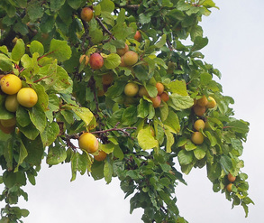

You will, I’m sure, have seen a large number of very heavy cropping yellow plum trees across both sites – but in particular a dedicated orchard at the far Eastern end – and wondered what they are. They are an old Heritage plum variety known as the Warwickshire Drooper and we have somewhere in the region of 50 of these across the 9 acres. They are not common and are something that we are very keen to capitalise on, as it will add further weight to the protection of our site.

The parents of the Warwickshire Drooper are not known but certainly many of the experts believe it originated from the Dundale Plum, bred in Kent during the early 1900s. However, they seem to have only appearance in common.

This variety was grown commercially by orchards in Warwickshire and the surrounding areas and was initially believed to be known as the Magnum. This is not certain because, in the Midlands, there are several plums trees containing the name Magnum. What is certain however, is that in the 1940s it became known by its current name - the Warwickshire Drooper.

When grown in commercial orchards this variety was typically grown on its own roots which made for a very large tree. To propagate the trees they would cut away the suckers and plant those. Nowadays however a smaller tree is more suited to modern gardens and the Warwickshire Drooper is commonly grown on the St Julien A rootstock which limits its size to 3m/10ft at maturity.

We are undertaking a plan to cultivate additional community orchards using the traditional technique of cultivation of the suckers so please don’t strim near the base of any existing trees until we have taken any suitable suckers. Many thanks.

# Warwickshire Droopers

**www.lansdowneallotmentassociation.co.uk**

We have been looking at the existing system (or lack of it) for dealing with the issue of composting. On the West site we have, historically, had a skip which has taken away all sorts of green material – some from site, some not! - whether it be readily compostable or not. RBC were happy to facilitate this, as they had quotas to meet from central government and this went directly toward that.

The East site have had something of an unmanaged pile which has not accounted for pervasive weeds or grading of compostable material.

The first thing to say is that we do not want the ongoing cost of skips when we are now directly responsible and when the majority of material that has been put into them is both compostable and reusable. So, there will no longer be a skip situated on the West site.

We are aware that a good proportion of plot holders do already self-manage their own composting so that the following may not apply to everyone. We are installing palletised compost areas on all new lets and have secured an ongoing supply on pallets for that purpose, and we will be giving best practice advice to all new plot holders. Should existing plot holders require assistance on setting up or running a compost area please contact a sub-committee member or leave a message with Pete in the shop.

We will be reorganising both sites to accommodate a graded system of composting (large stuff at one end, small at the other) so that all green waste can be managed, composted down and then be made available for reuse. There will be water tanks adjacent to the composting areas for pervasive weed i.e. couch grass and bind weed as that will rot down in water and become a fertiliser in its own right.

All plot holders using this facility MUST use it properly and put waste into the correct areas. It is for the disposal of site waste only. No exceptions will be made and contravention of this could result in termination of tenancy. (See section 8.1.7)

All compost produced will then be made available back to plot holders and there will no cost for this provision in the short term.

# Composting

Our sincere thanks go to Bill on Plot 54 for his help in organising a very substantial and lockable shipping container for us to store assorted equipment.

Our thanks also go to Keller for providing the container and organising its transportation and siting.

# Container & Tools

**Sub Committee East**

Rob Brocklehurst Plot 19 (Chair)

Jenny Farley Plot 62 (Intro Officer)

Gordon Griffiths Plot 65

Sally Tottman Plot 112

**Sub Committee West**

Karl Hine Plot 10 (Chair)

Tony Hill Plot 6 (Intro Officer)

Daphne Codling Plot 40

John and Sandy Young Plot 9

John and Sandy are both Master Composters and will be available to offer both support and advice to plot holders across both sites.

**Lansdowne Allotment Association Committee**

Karl Hine Plot 10 (Chair)

Teresa Yates Plot 8 (Secretary)

Pete McTeigue Plot 52 and the Shop (Treasurer)

Rob Brocklehurst Plot 19

Jenny Farley Plot 62

Tony Hill Plot 6

Gavin Parry Plot 11

Cllr Jerry Roodhouse Plot 31

# Your Committees

We have applied for a Grant of £1000 from our local councillor and are in the process of finalising another couple of applications before their cut off dates.

We are obviously looking to secure as much funding as is possible right from the start, as we now have to take care of all on-site maintenance with immediate effect and to do this effectively we will need a range of equipment.

We will keep you informed.

# Grants

**www.lansdowneallotmentassociation.co.uk**